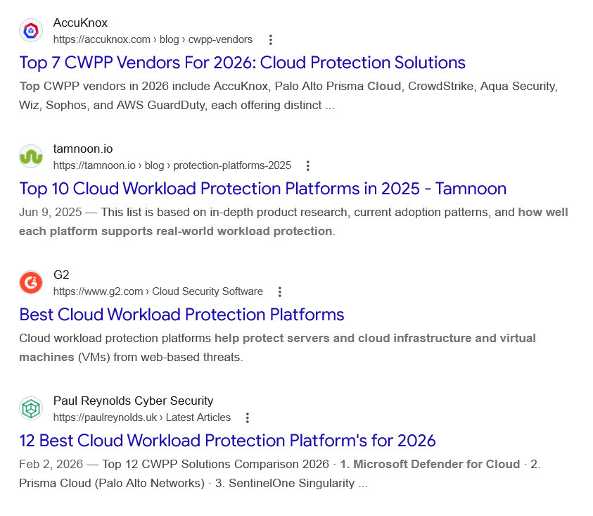
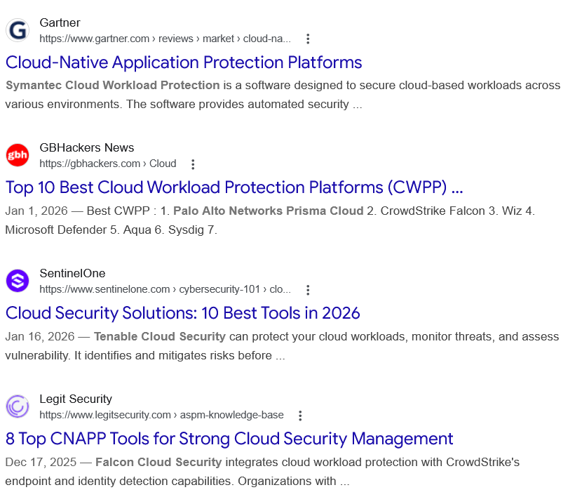
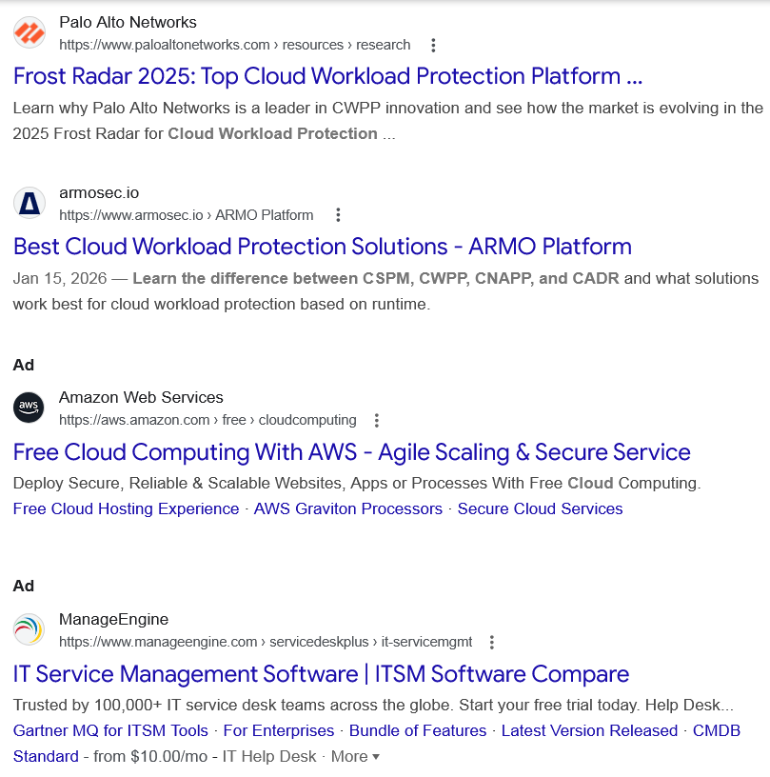
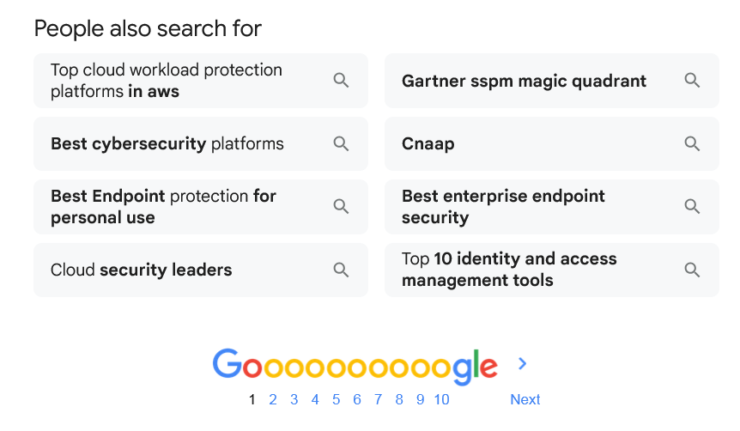

Web results

Top 7 CWPP Vendors For 2026: Cloud Protection Solutions

AccuKnox
https://accuknox.com › blog › cwpp-vendors

AccuKnox
https://accuknox.com › blog › cwpp-vendors
Top CWPP vendors in 2026 include AccuKnox, Palo Alto Prisma Cloud, CrowdStrike, Aqua Security, Wiz, Sophos, and AWS GuardDuty, each offering distinct ...

Top 10 Cloud Workload Protection Platforms in 2025 - Tamnoon

tamnoon.io
https://tamnoon.io › blog › protection-platforms-2025

tamnoon.io
https://tamnoon.io › blog › protection-platforms-2025
Jun 9, 2025 — This list is based on in-depth product research, current adoption patterns, and how well each platform supports real-world workload protection.

Best Cloud Workload Protection Platforms

G2
https://www.g2.com › Cloud Security Software

G2
https://www.g2.com › Cloud Security Software
Cloud workload protection platforms help protect servers and cloud infrastructure and virtual machines (VMs) from web-based threats.

12 Best Cloud Workload Protection Platform's for 2026

Paul Reynolds Cyber Security
https://paulreynolds.uk › Latest Articles

Paul Reynolds Cyber Security
https://paulreynolds.uk › Latest Articles
Feb 2, 2026 — Top 12 CWPP Solutions Comparison 2026 · 1. Microsoft Defender for Cloud · 2. Prisma Cloud (Palo Alto Networks) · 3. SentinelOne Singularity ...

Cloud-Native Application Protection Platforms

Gartner
https://www.gartner.com › reviews › market › cloud-na...

Gartner
https://www.gartner.com › reviews › market › cloud-na...
Symantec Cloud Workload Protection is a software designed to secure cloud-based workloads across various environments. The software provides automated security ...

Top 10 Best Cloud Workload Protection Platforms (CWPP) ...

GBHackers News
https://gbhackers.com › Cloud

GBHackers News
https://gbhackers.com › Cloud
Jan 1, 2026 — Best CWPP : 1. Palo Alto Networks Prisma Cloud 2. CrowdStrike Falcon 3. Wiz 4. Microsoft Defender 5. Aqua 6. Sysdig 7.

Cloud Security Solutions: 10 Best Tools in 2026

SentinelOne
https://www.sentinelone.com › cybersecurity-101 › clo...

SentinelOne
https://www.sentinelone.com › cybersecurity-101 › clo...
Jan 16, 2026 — Tenable Cloud Security can protect your cloud workloads, monitor threats, and assess vulnerability. It identifies and mitigates risks before ...

8 Top CNAPP Tools for Strong Cloud Security Management

Legit Security
https://www.legitsecurity.com › aspm-knowledge-base

Legit Security
https://www.legitsecurity.com › aspm-knowledge-base
Dec 17, 2025 — Falcon Cloud Security integrates cloud workload protection with CrowdStrike's endpoint and identity detection capabilities. Organizations with ...

Frost Radar 2025: Top Cloud Workload Protection Platform ...

Palo Alto Networks
https://www.paloaltonetworks.com › resources › research

Palo Alto Networks
https://www.paloaltonetworks.com › resources › research
Learn why Palo Alto Networks is a leader in CWPP innovation and see how the market is evolving in the 2025 Frost Radar for Cloud Workload Protection ...

Best Cloud Workload Protection Solutions - ARMO Platform

armosec.io
https://www.armosec.io › ARMO Platform

armosec.io
https://www.armosec.io › ARMO Platform
Jan 15, 2026 — Learn the difference between CSPM, CWPP, CNAPP, and CADR and what solutions work best for cloud workload protection based on runtime.
Ad

Free Cloud Computing With AWS - Agile Scaling & Secure Service

Amazon Web Services
https://aws.amazon.com › free › cloudcomputing

Amazon Web Services
https://aws.amazon.com › free › cloudcomputing
My Ad Centre
Deploy Secure, Reliable & Scalable Websites, Apps or Processes With Free Cloud Computing.
‎Free Cloud Hosting Experience · ‎AWS Graviton Processors · ‎Secure Cloud Services
Ad

IT Service Management Software | ITSM Software Compare

ManageEngine
https://www.manageengine.com › servicedeskplus › it-servicemgmt

ManageEngine
https://www.manageengine.com › servicedeskplus › it-servicemgmt
My Ad Centre
Trusted by 100,000+ IT service desk teams across the globe. Start your free trial today. Help Desk...
‎Gartner MQ for ITSM Tools · ‎For Enterprises · ‎Bundle of Features · ‎Latest Version Released · ‎CMDB
Standard - from $10.00/mo - IT Help Desk
· More

People also search for

Top cloud workload protection platforms in aws

Best cybersecurity platforms

Best Endpoint protection for personal use

Cloud security leaders

Gartner sspm magic quadrant

Cnaap

Best enterprise endpoint security

Top 10 identity and access management tools

Page navigation
 | 1 | 2 | 3 | 4 | 5 | 6 | 7 | 8 | 9 | 10 | Next

